Real-time Synchronome

Mason McGaffin
ECEN 5623 Real-time Embedded Systems
Dr. Sam Siewert
University of Colorado Boulder
July 26, 2026

Contents
Introduction 2
Functional Requirements 2
Real-time Requirements 3
Functional Design Overview 4
Detailed Design 6
Sequencer Thread 6
Acquisition Thread 7
Processing Thread 7
Write-Back Thread 8
Real-Time Analysis 9
One Hz System 9
Ten Hz System 10
Embedded Performance Analysis 12
Results 12
One Hz System 12
Ten Hz System 14
Conclusion 16
References 17
Appendix 18

Introduction
Real-time embedded systems must satisfy both functional and timing requirements to ensure deterministic behavior. In applications such as robotics, autonomous systems, and industrial automation, missing a deadline can be as detrimental as producing an incorrect result. The objective of this project was to design, implement, and evaluate a periodic real-time image synchronization system capable of acquiring images from the Logitech C920x Pro Webcam, selecting the highest-quality frame at a specified output frequency, one or ten Hz, and saving the selected images to disk. The system was implemented on the NVIDIA Jetson Orin Nano using POSIX threads, semaphores, the Video4Linux2 (V4L2) interface, and SCHED_FIFO real-time scheduling policy. Two implementations were developed to satisfy the project requirements: a one-hertz system and a ten-hertz system, both sharing the same software architecture while differing only in their execution rates. System performance is evaluated through Rate Monotonic analysis and experimental measurements of execution time, processor utilization, release jitter, and timing drift to verify that all periodic deadlines are consistently satisfied. The resulting systems implemented a real-time Synchronome at the respective processing speeds.

Functional Requirements
Description | Requirement | Result
Accepts webcam input | The application shall accept live video input from the Logitech C920X Pro HD Webcam. | ✅ The application initializes the camera using V4L2 at a maximum input rate of 30FPS.
Executes Periodic Processing | The application shall use at least two periodic tasks. | ✅ The application uses three periodic threads: sequencer, acquisition, and processing. The sequencer sleeps according to the POSIX clock and releases the acquisition and processing threads.
Save highest-quality frame as PPM image. | The application shall save the clear frames of each tick/stopwatch increment to PPM image files. | ✅ The application saves frames to the “frames” directory as PPM images.
Maintain real-time deadlines | Periodic tasks shall never miss a real-time deadline. | ✅ The periodic tasks never miss a deadline even when the write-back thread blocks.
Log timing information | The application shall produce use a timing tracing method to evaluate timing and performance | ✅ The system uses syslog traces to record significant events: start/stop of each main service (acquisition, processing, write-back). Python scripts are used to parse and visualize timing and real-time performance.

Real-time Requirements
One Hz
Service | Purpose | C (3x measured) (ms) | T (ms) | D (ms) | P
Sequencer | Release Periodic Tasks | 1 | 100 | 100 | 80
Acquisition | Capture Webcam Frame | 3 | 200 | 200 | 70
Processing | Score and Select Best Frame | 33 | 1000 | 1000 | 60
Write-Back | Write Best Frame to Disk | N/A | N/A | Best effort | N/A
Ten Hz
Service | Purpose | C (3x measured) (ms) | T (ms) | D (ms) | P
Sequencer | Release Periodic Tasks | 1 | 3.3333 | 3.3333 | 80
Acquisition | Capture Webcam Frame | 3 | 33.333 | 33.333 | 70
Processing | Score and Select Best Frame | 33 | 100 | 100 | 60
Write-Back | Write Best Frame to Disk | N/A | N/A | Best effort | N/A
The real-time requirements were determined based on the timing requirements of the challenge and period synchronization. The sequencer was chosen to run at a rate faster than the next fastest task in order to minimize jitter of the POSIX clock_nanosleep() function. By oversampling, we can ensure that services are released more accurately.
The Write-Back service is not a real-time service because of SD Card blocking that can cause latency. As further discussed later in the paper, the write-back is a best effort service in order to preserve accurate timing of real-time services.
For the One Hz system, the base timing constraint is that one frame must be selected for each clock tick (every second). For this reason, the processing task is chosen to score and select a single frame every second (1000 ms). To oversample the camera input, the acquisition service was selected to run five times faster (every 200ms) than the processing service in order to provide five frames to choose from each processing period. The sequencer was chosen to be twice as fast as the acquisition service (every 100ms).
For the Ten Hz system, the base timing constraint is that one frame must be selected for each tenth of a second increment of the digital stopwatch. For this reason, the processing task is configured to score and select a frame every 100ms. Unfortunately, due to the hardware limitations of the Logitech C920x Pro Webcam, the maximum frame rate is 30FPS. Therefore, the acquisition service cannot be run faster than 30 Hz (33.333 ms period). In order to get a harmonic interval for the sequencer, acquisition, and processing task, we select the sequencer to run at ten times the rate of the acquisition thread – 300 Hz (3.333 ms period).
Deadlines were chosen equal to task periods according to Rate Monotonic Scheduling and because each task must complete before its next release. Fixed priorities were assigned according to Rate Monotonic scheduling. Since the sequencer has the shortest period, it receives the highest priority. Acquisition executes next because camera sampling must remain deterministic. Processing has the lowest real-time priority because it executes least frequently. The writer thread is intentionally excluded from the real-time task set and executes under SCHED_OTHER to prevent blocking disk operations from delaying periodic services.
The execution times reported in the table correspond to the triple the worst measured execution times collected during experimental testing. These values are later used for Rate Monotonic feasibility analysis in Real-Time Analysis. Because image acquisition and processing have very low execution-time variability, the measured values provide a reasonable approximation of WCET for this application but we overestimate to be cautious. The write-back execution time is not applicable given that it is a best effort service and is susceptible to longer execution times due to SD Card blocking.

Functional Design Overview
The system operates continuously after initialization. During startup, the application configures the USB webcam using the Linux V4L2 interface, allocates memory-mapped capture buffers, initializes the input and write-back ring buffers, creates the required semaphores and synchronization primitives, and enables video streaming. Then, the acquisition, processing, writer, and sequencer threads are created with their assigned scheduling policies, priorities, and CPU affinities before entering continuous operation.
The application consists of four (4) cooperating threads—sequencer, acquisition, processing, and write-back. The sequencer thread serves as the timing source for the system by periodically releasing the acquisition and processing threads according to the desired execution frequencies. The acquisition thread captures image frames from the camera and stores them in the shared input ring buffer. The processing thread periodically evaluates the candidate frames, computes a score for each candidate using temporal difference and spatial gradient, and selects the highest-quality frame for output. The selected frame is then transferred to the write-back ring buffer, where the write-back thread converts the image from YUYV to RGB format and saves it as a timestamped PPM image. The block diagram below illustrates the data flow through each stage, along with the two fixed size ring buffers. These ring buffers allow acquisition and processing to continue executing independently if another stage is temporarily delayed. This separation is particularly important because file writes to the SD card can occasionally block for extended periods, causing significant latency without impacting the timing of the real-time services.
After the required number of output frames has been generated, the write-back thread signals the other threads stop. The sequencer then releases any blocked real-time threads, allowing the acquisition and processing services to complete their remaining work before all threads are joined and system resources are gracefully released.
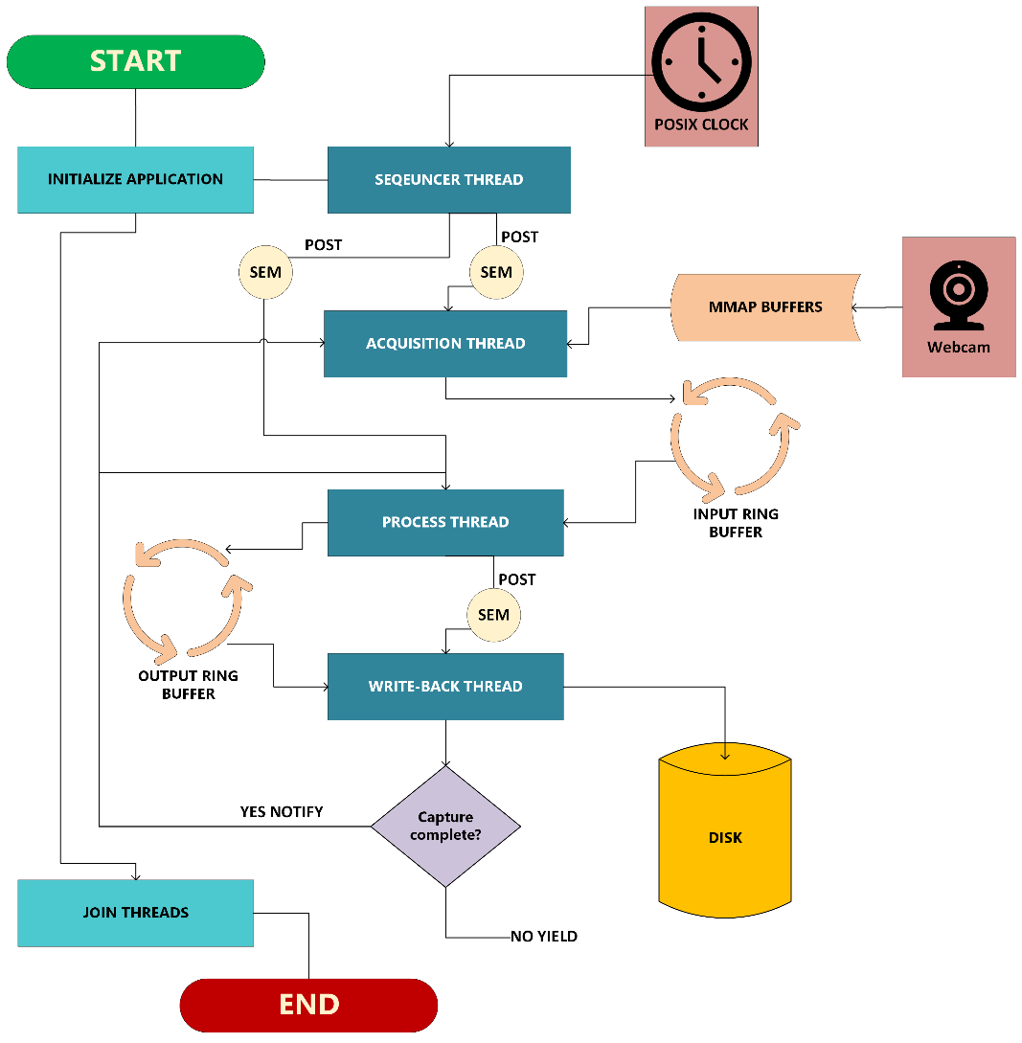
Block Diagram

Detailed Design
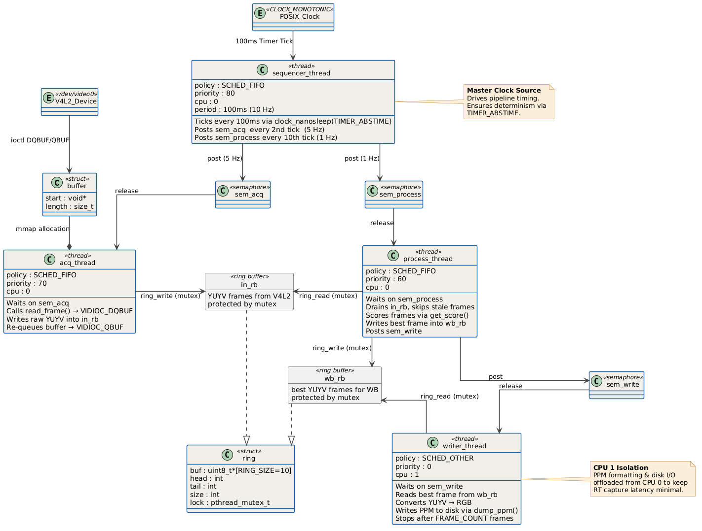
Class Diagram

Sequencer Thread
The sequencer thread is responsible for periodically releasing the other real-time services according to the system schedule. Rather than performing any image processing itself, the sequencer serves as the timing source for the application by releasing the acquisition and processing threads at fixed intervals using POSIX semaphores. This architecture ensures that all real-time tasks are executed at deterministic periods independent of their execution time.
Upon initialization, the sequencer records the initial monotonic clock time and repeatedly sleeps until the next absolute release time using clock_nanosleep() with TIMER_ABSTIME. Future work could be to replace clock_nanosleep() with a more reliable timer to further reduce jitter. For the One Hz System, the sequencer woke every 100ms (10 Hz) to increment an execution counter. It releases the acquisition thread every second period (5 Hz) and the processing thread every tenth period (1 Hz). For the Ten Hz System, the sequencer awake every 3.333ms (300 Hz), releases acquisition every tenth (10th) period (30 Hz) and processing every 30th period (10 Hz). Oversampling the sequencer guarantees consistent periodic execution while minimizing release jitter.

while running:
sleep_until_next_period()
if period % 2 == 0:
release(acquisition)
if period % 10 == 0:
release(processing)
Pseudocode for Sequencer Thread

Acquisition Thread
The acquisition thread is responsible for periodically retrieving image frames from the USB webcam using the Linux V4L2 driver. The thread executes independently from processing and write-back operations so that image capture remains deterministic regardless of downstream delays. During initialization, the acquisition thread configures the camera for 640×480 YUYV video using memory-mapped I/O buffers. After being released by the sequencer, the thread dequeues the next camera buffer, copies the frame into the shared input ring buffer, records a timestamp for performance tracing, and requeues the camera buffer for future captures.
while running:
wait()
timestamp()
frame = read_frame()
input_ring.push(frame)
timestamp()
Pseudocode for Acquisition Thread
Thread synchronization is accomplished using a mutex protecting the shared input ring buffer. The mutex prevents concurrent modifications while the acquisition thread writes new frames and the processing thread reads frames. The ring buffer allows the acquisition thread to continue receiving images while processing executes independently, preventing camera capture delays from affecting other services. Separating frame acquisition into its own high-priority thread ensures deterministic camera sampling and prevents write-back delays from impacting capture.

Processing Thread
The processing thread is responsible for selecting the highest-quality image from the recently captured frames. After being released by the sequencer, the processing thread records a timestamp, removes the available frames captured since the last run from the input ring buffer, computes a score using temporal differences and spatial gradients for each candidate frame relative to the previous output frame, and retains the frame with the highest score. Once the best frame has been identified, it is placed into the write-back ring buffer, and the writer thread is released using a semaphore.
while running:
wait()
timestamp()
while input_ring not empty:
frame = input_ring.pop()
score = get_score(frame)
if score > best_score
best_frame = frame
output_ring.push(best_frame)
timestamp
release(write_back)
Pseudocode for Processing Thread
The processing thread is synchronized with the acquisition thread through the shared input ring buffer protected by a mutex. This synchronization prevents race conditions while allowing acquisition and processing to execute concurrently. The selected frame is then transferred to the output ring buffer, where it becomes available for the writer thread. The output ring buffer is also protected by a mutex. Processing is a separate thread because it allows the more computationally intensive scoring operations to execute without impacting the deterministic timing of image capture. It also prevents processing from being blocked by write-back delays.

Write-Back Thread
The write-back thread is responsible for converting the selected YUYV frame into RGB format and saving the resulting frame as a PPM image. Unlike the real-time services, the writer executes as a best-effort task using the Linux SCHED_OTHER scheduling policy. After receiving a semaphore from the processing thread, the writer removes the selected frame from the output ring buffer, converts each pair of YUYV pixels into RGB values, timestamps the output image, and writes the completed PPM file to disk.
while running:
wait()
timestamp()
frame = output_ring.pop()
rgb_frame = convert_rgb(frame)
save_ppm(rgb_frame)
timestamp()
Pseudocode for Write-Back Thread
The writer thread is synchronized with the processing thread through the output ring buffer protected by a mutex. The real-time services never wait for file I/O to complete. This is very important because occasionally the SD Card driver will block when continuous write operations are executed. This causes temporary write-back latency. By separating this task, the upstream tasks of input capture and frame processing can continue without blocking. It also allows the writer to catch back up on saving frames after the SD Card blocking is lifted.

Real-Time Analysis
Both the One Hz and Ten Hz systems employ fixed priority preemptive scheduling using the POSIX SCHED_FIFO policy. Thread priorities were assigned according to Rate Monotonic (RM) theory where tasks with shorter periods have higher priorities. Each task period is equal to its respective deadline in accordance with RM as the task must finish before its next execution release. The write-back thread is intentionally excluded from the real-time services due to the non-deterministic I/O blocking due to the SD Card filesystem. Therefore, the thread executes independently using the POSIX SCHED_OTHER policy, free to use any available CPU core.

One Hz System
Service | Purpose | C (measured) (ms) | T (ms) | D (ms) | P
Sequencer | Release Periodic Tasks | 0.3 | 100 | 100 | 80
Acquisition | Capture Webcam Frame | 0.8 | 200 | 200 | 70
Processing | Score and Select Best Frame | 11.0 | 1000 | 1000 | 60
Write-Back | Write Best Frame to Disk | N/A | N/A | Best effort | N/A
The execution times recorded above represent a rounded up approximation of the measured execution time using the syslog trace parsing. See below.
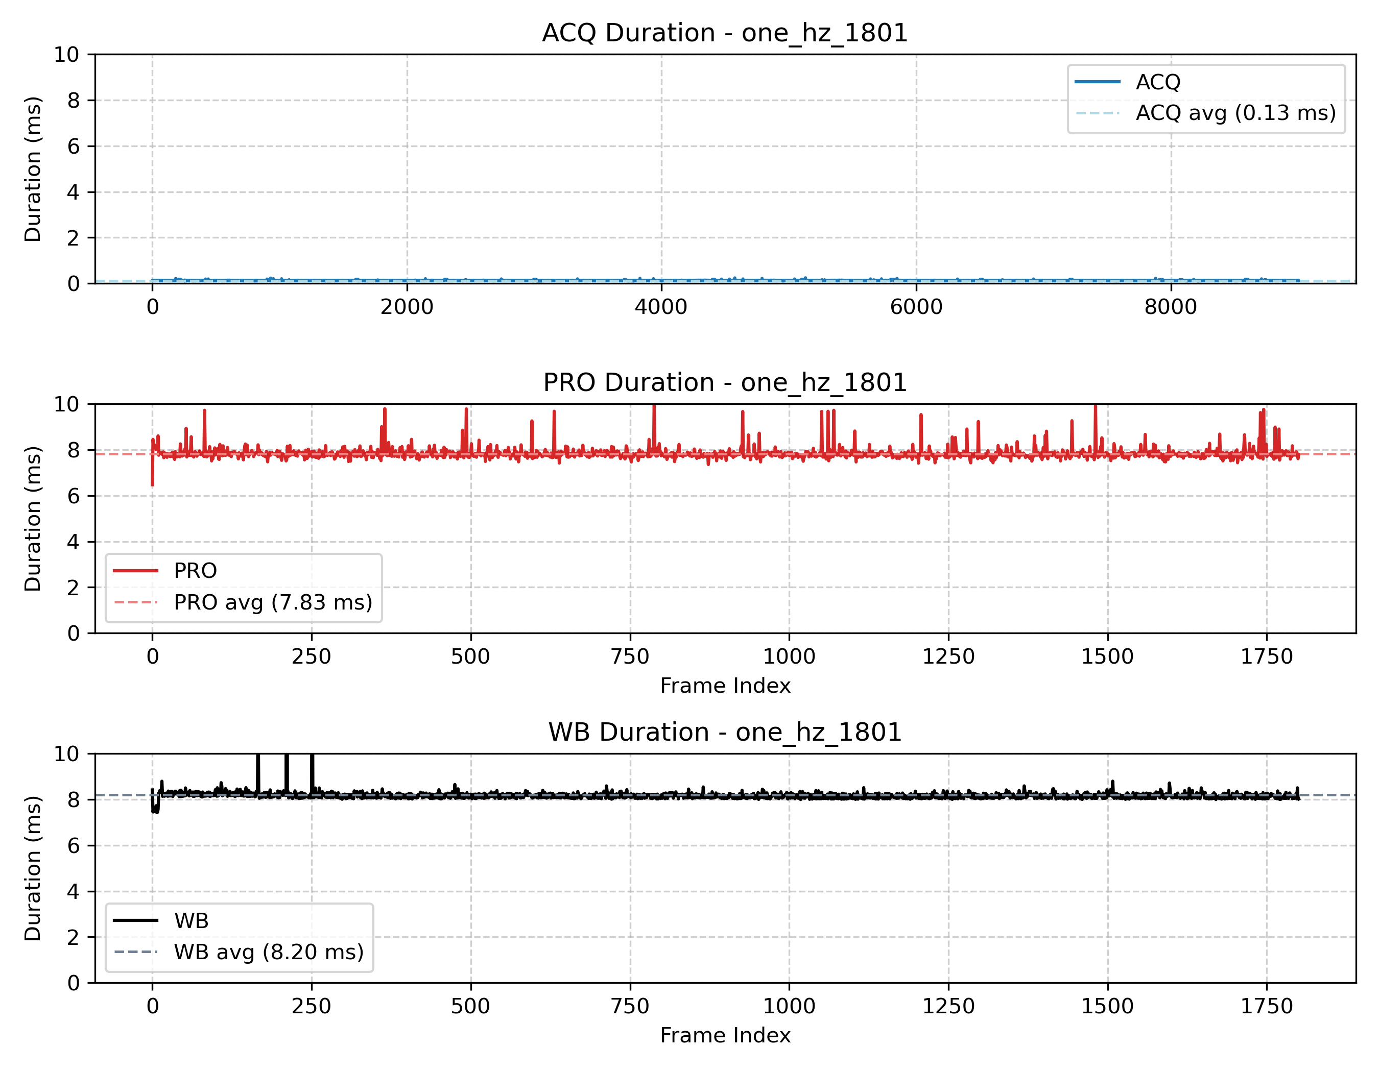
One Hz execution times for 1801 frames test
For RM analysis, we will over approximate these measured maximums to the Real-time Requirements. As seen in the equation below, the combined utilization of the real-time tasks is less than the Liu & Layland maximum upper bound. This ensures schedulability. Reference the Cheddar output Below to see worst case execution times if all three tasks are released at the same time.
3X Worst Case Execution:
$$U=\frac{1}{100}+\frac{3}{200}+\frac{33}{1000}=0.058≤0.780=3*\left(2^{1/3}-1\right)$$
Measured Worst Case Execution:
$$U=\frac{0.3}{100}+\frac{0.8}{200}+\frac{11}{1000}=0.018$$
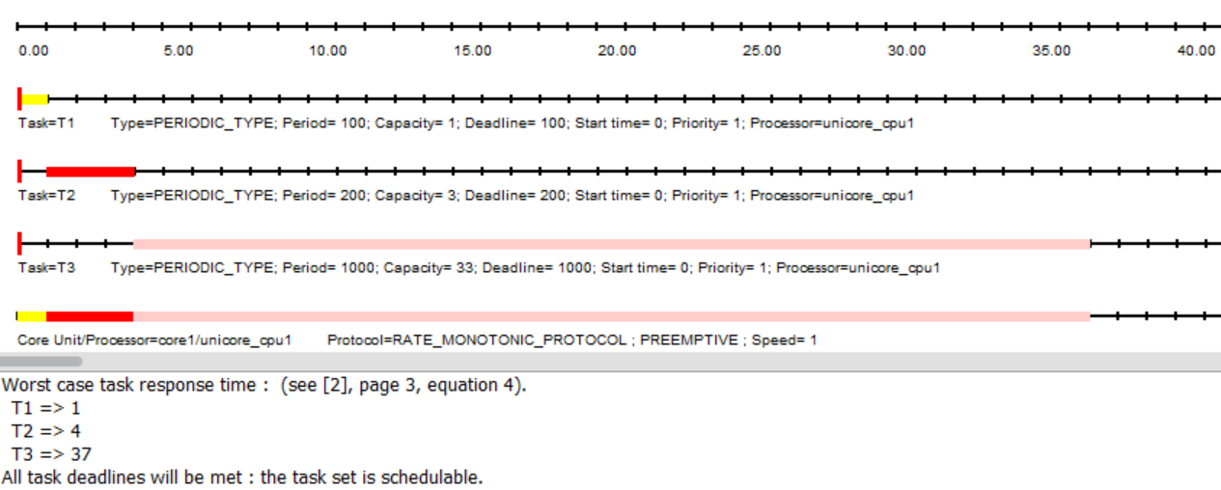
Cheddar Analysis for One Hz system

Ten Hz System
Service | Purpose | C (measured) (ms) | T (ms) | D (ms) | P
Sequencer | Release Periodic Tasks | 0.3 | 3.3333 | 3.3333 | 80
Acquisition | Capture Webcam Frame | 0.8 | 33.333 | 33.333 | 70
Processing | Score and Select Best Frame | 11 | 100 | 100 | 60
Write-Back | Write Best Frame to Disk | N/A | N/A | Best effort | N/A
The execution times recorded above represent a rounded up approximation of the measured execution time using the syslog trace parsing. See below.
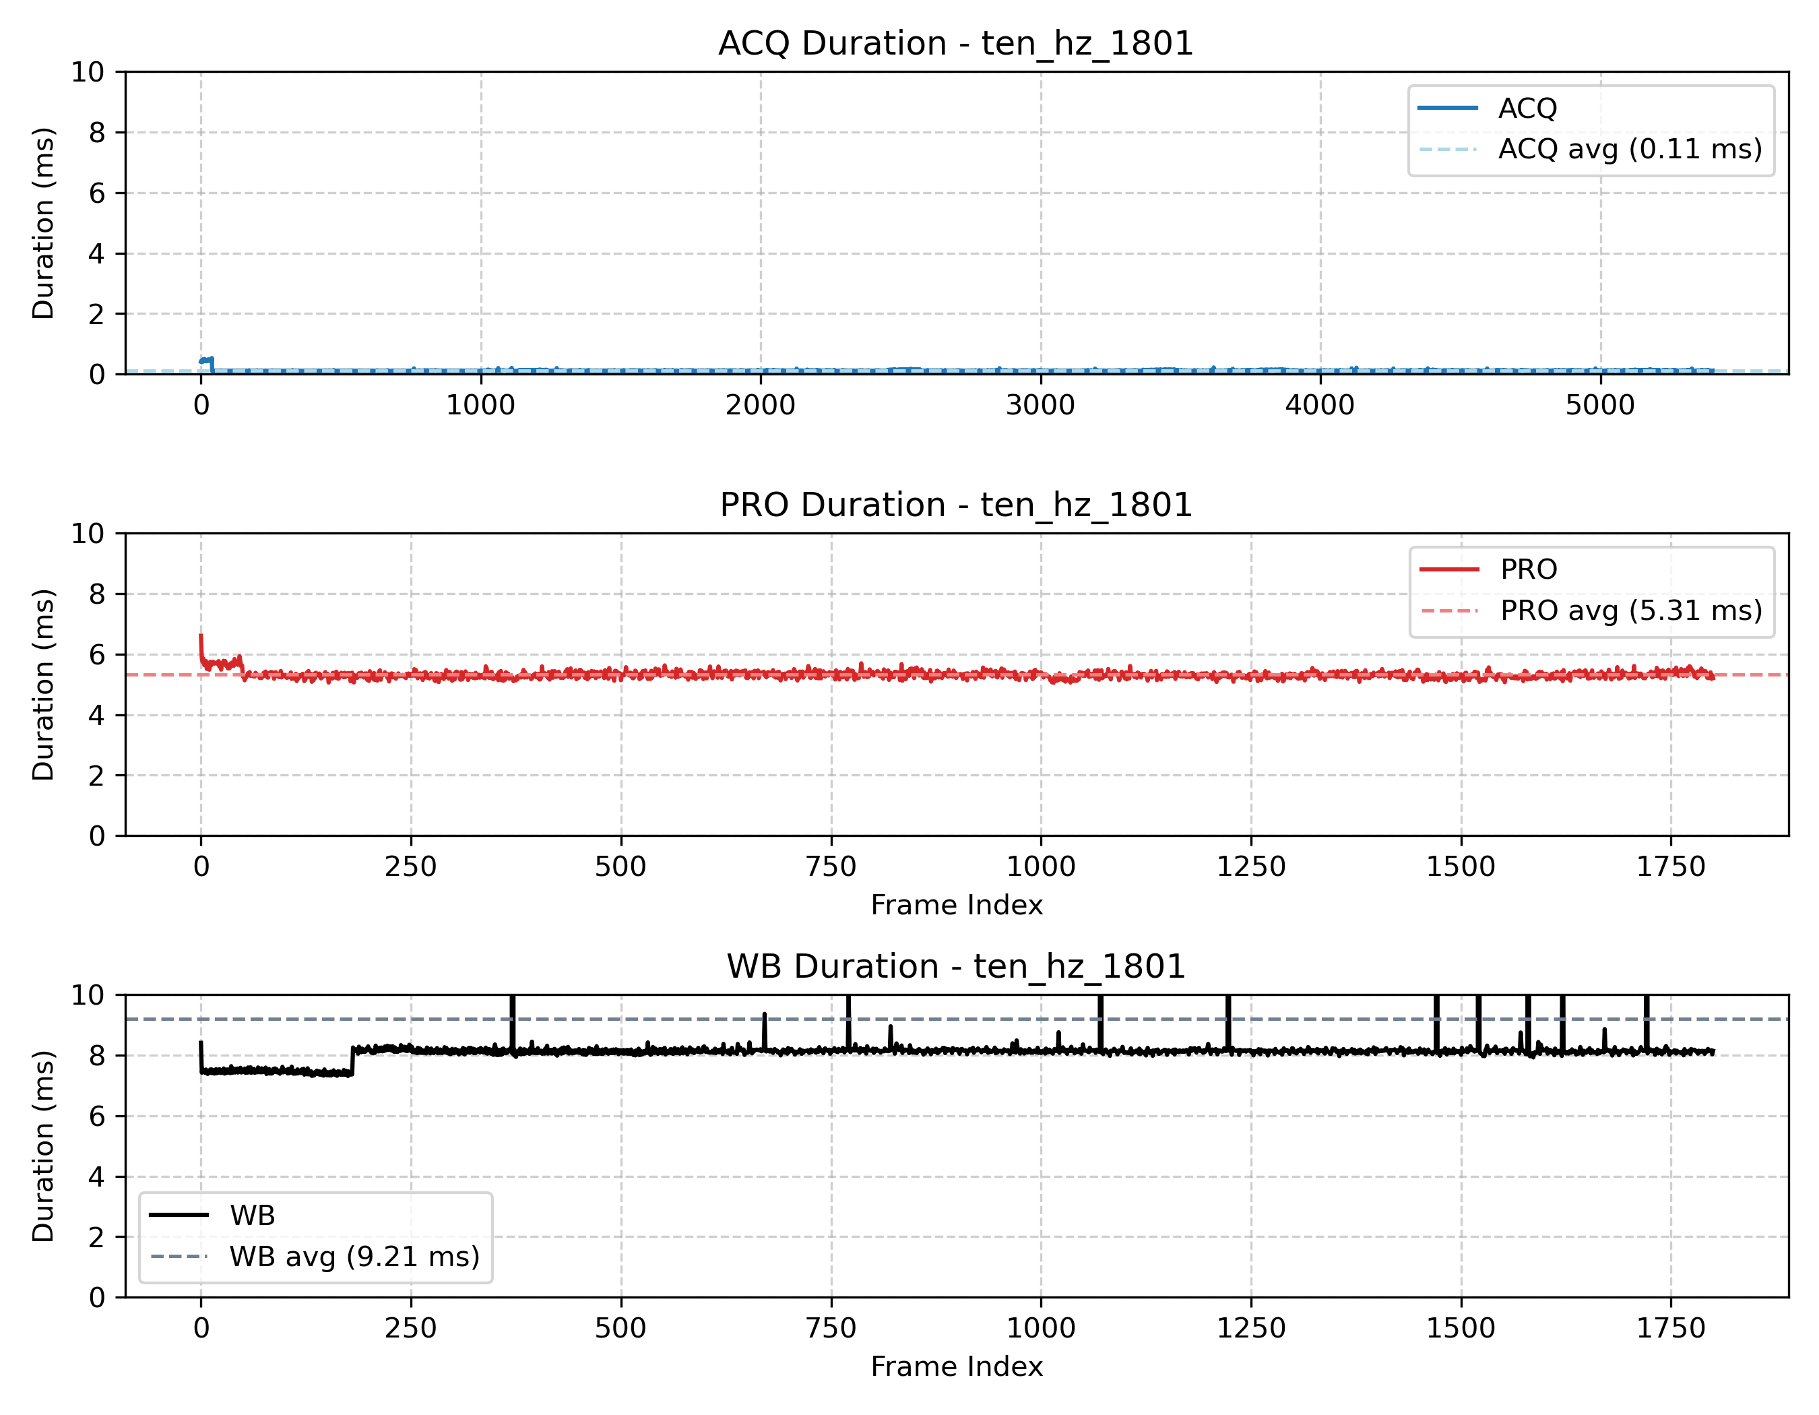
Ten Hz execution times for 1801 frames test
Again for RM analysis, we will over approximate these measured maximums to the Real-time Requirements. As seen in the equation below, the combined utilization of the real-time tasks is less than the Liu & Layland maximum upper bound. This ensures schedulability. Reference the Cheddar output Below to see worst case execution times if all three tasks are released at the same time. The actual utilization is about 2-3 times less than this metric but it proves the services are schedulable.
3X Worst Case Execution:
$$U=\frac{1}{3}+\frac{3}{33}+\frac{33}{100}=0.754≤0.780=3*\left(2^{1/3}-1\right)$$
Measured Worst Case Execution:
$$U=\frac{0.3}{3}+\frac{0.8}{33}+\frac{11}{100}=0.234$$
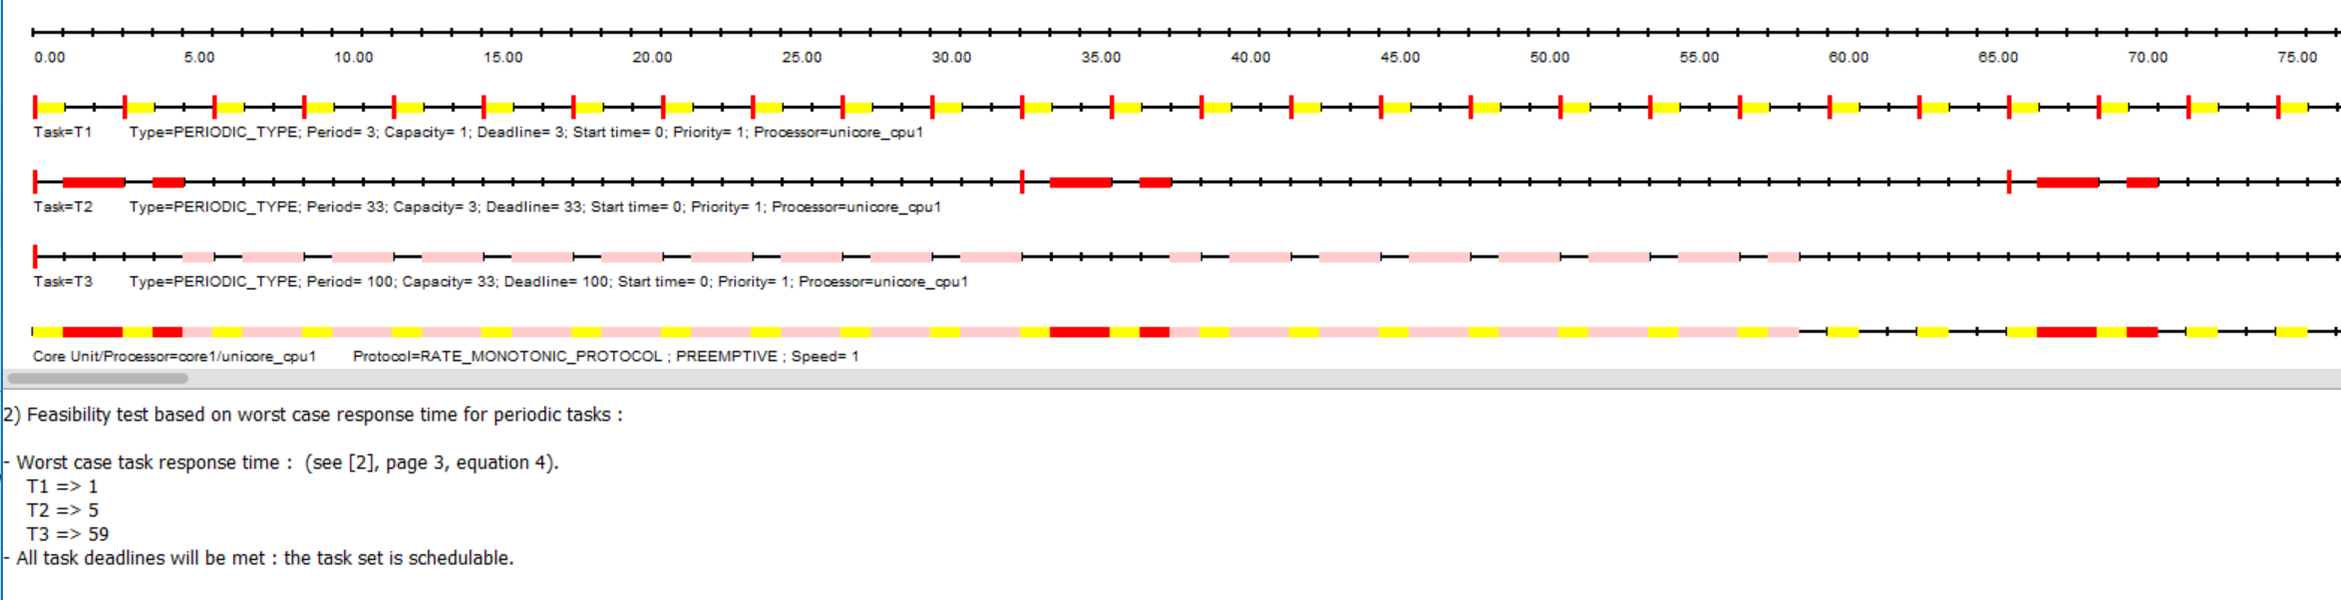
Cheddar Analysis for Ten Hz system

Embedded Performance Analysis
Test | Input FPS | Output FPS | Overall CPU Max Usage | CPU Core 0 Max Usage | RAM (MB)
One Hz | 5 | 1 | 10% | 25% | 61MB
Ten Hz | 30 | 10 | 15% | 30% | 97MB
As you can see, the application is running well within the limits of the six core NVIDIA Jetson Orin Nano which contains 7.6G of RAM.
The Appendix contains zip files with more figures that demonstrate the performance of the embedded application.

Results

One Hz System
The One Hz system correctly and deterministically selected clear frames from each tick of the analog clock. The frames, as seen below were clear and distinct. The jitter and drift of the real-time services is exemplified in the charts following.
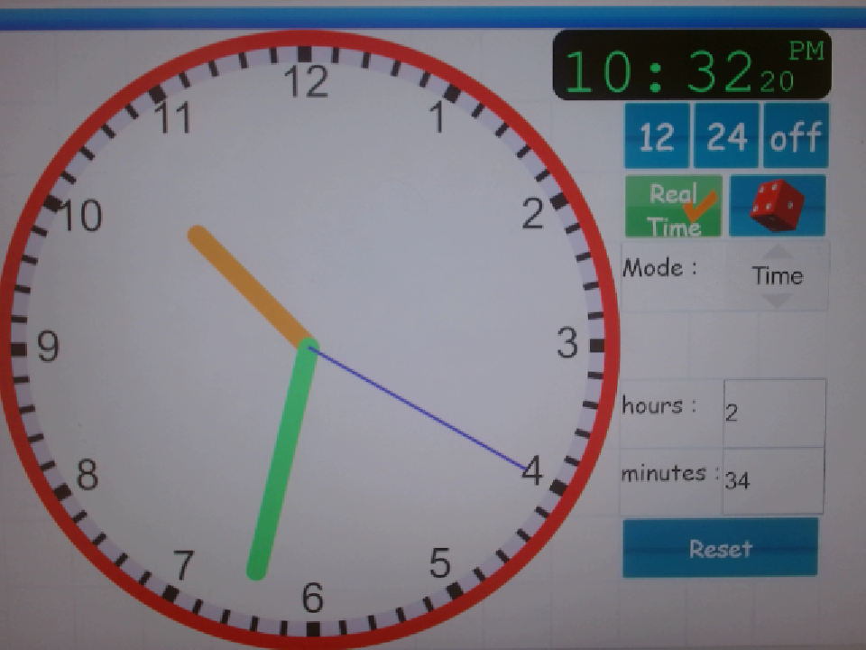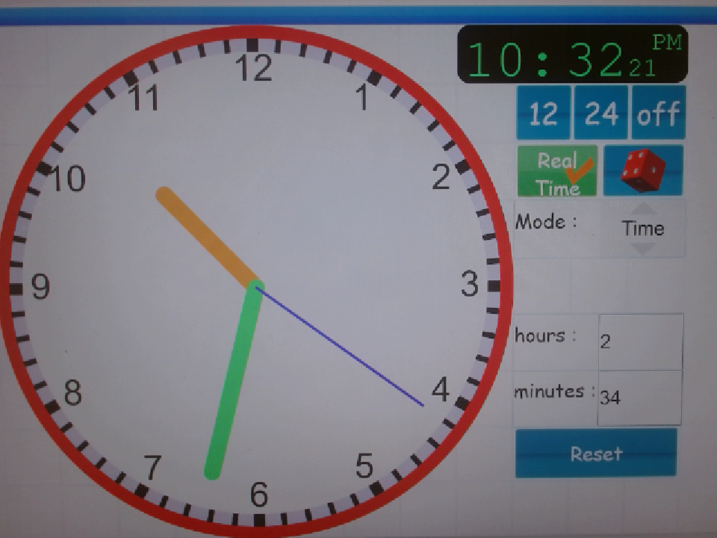
First three frames of One Hz system test of 181 frames
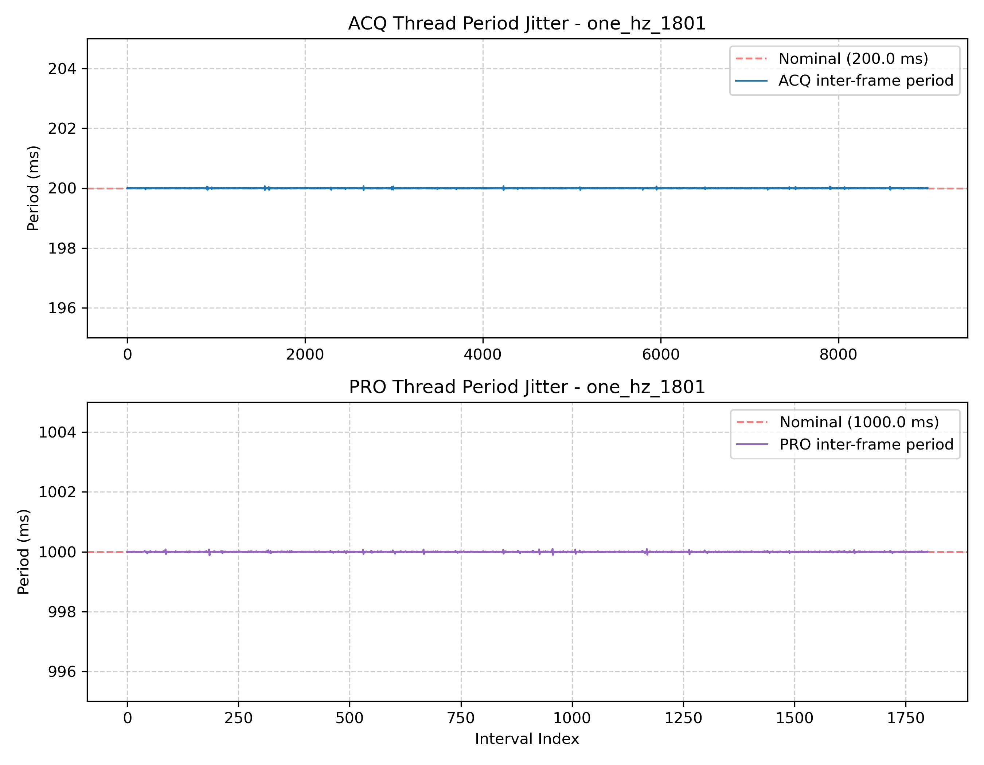
One Hz system jitter for 1801 frames test
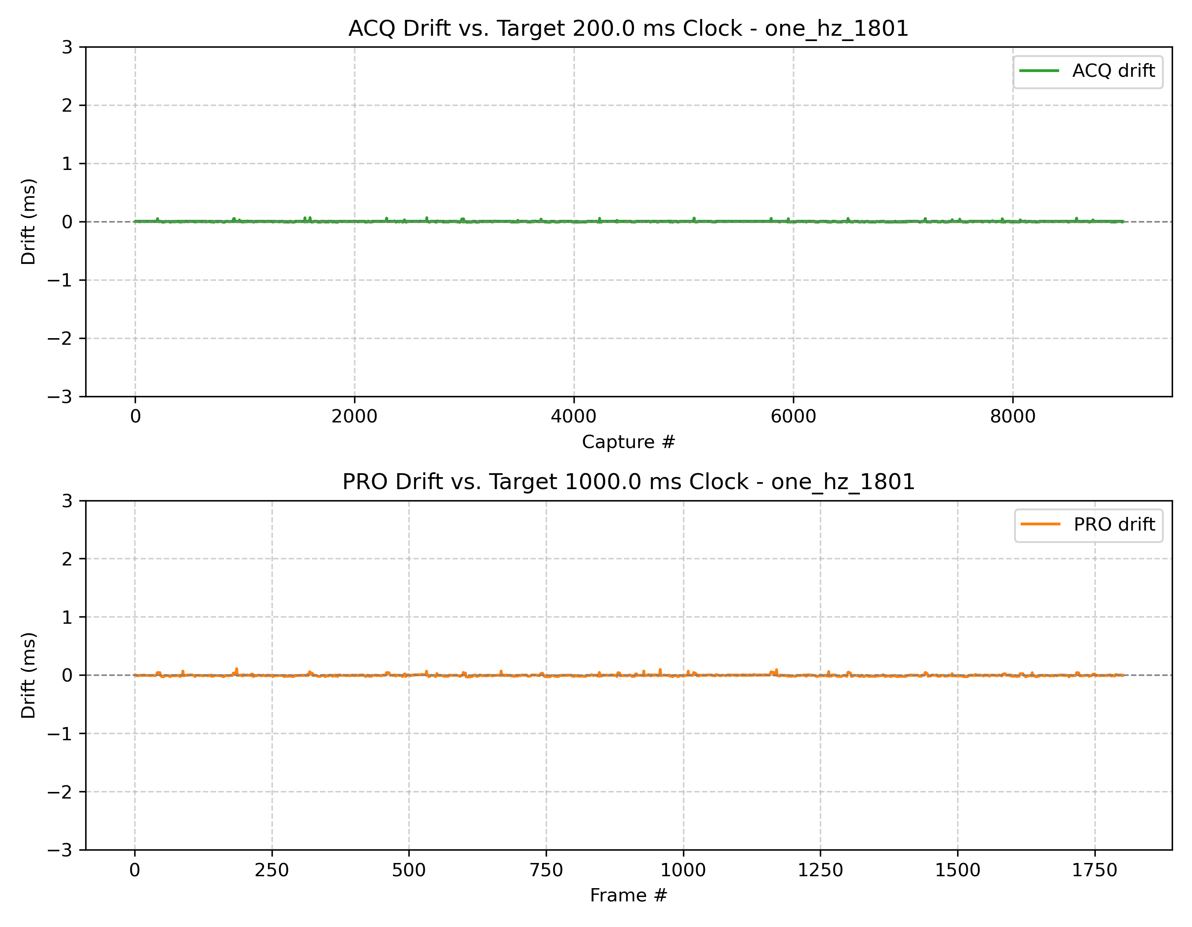
One Hz system drift for 1801 frames test
As seen in the figures above, the jitter (max 0.12ms) and drift (max 0.11ms) are negligible compared to the requirements of the system. The execution times of each thread are documented in Real-Time Analysis.

Ten Hz System
The Ten Hz system correctly and deterministically selected clear frames from each tenth of second increment of the digital stopwatch. The frames, as seen below were distinct. One issue that was encountered was getting very clear frames, occasionally, the get_score() algorithm did not properly handle the blurriness from the incrementing tenth of a second. The jitter and drift of the real-time services is exemplified in the charts following.
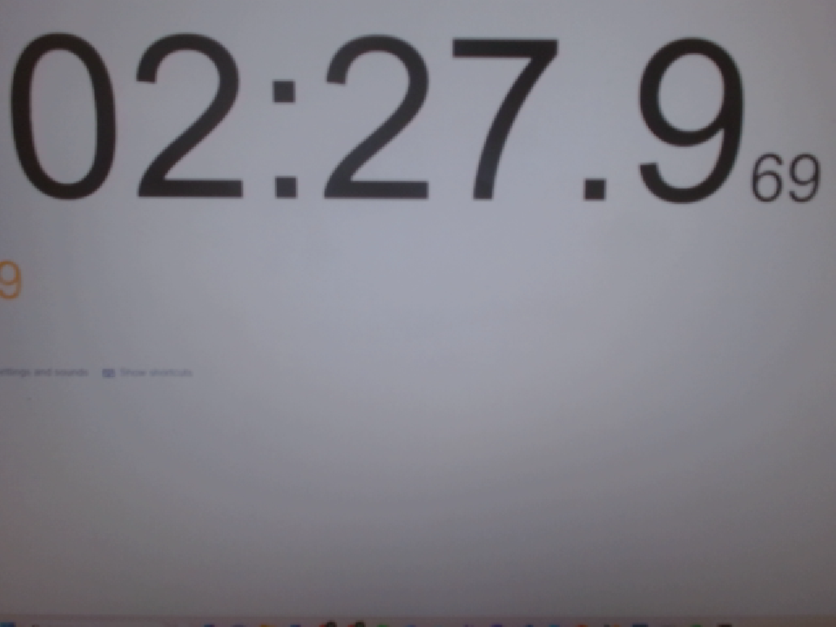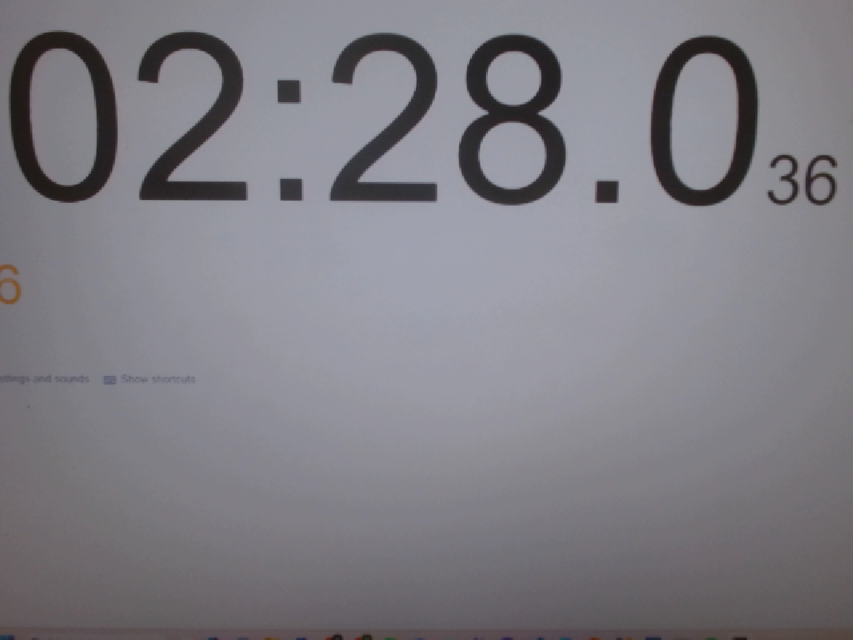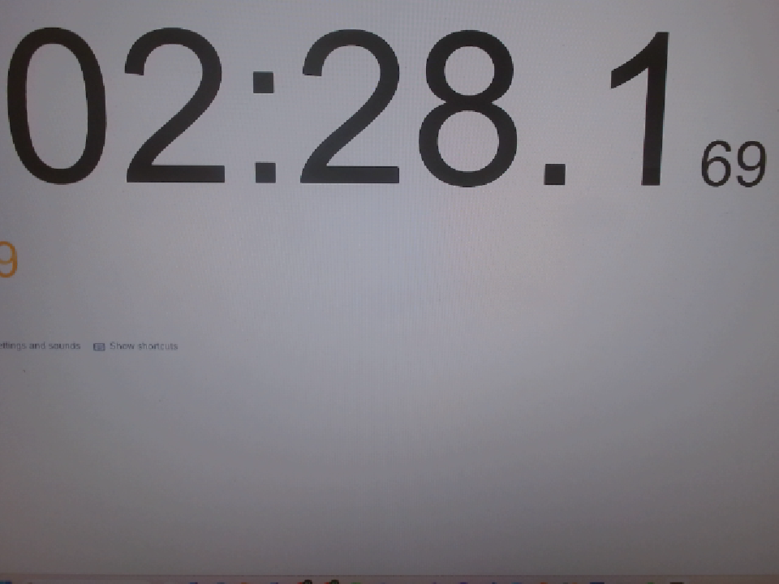
First three frames of Ten Hz system test for 181 frames
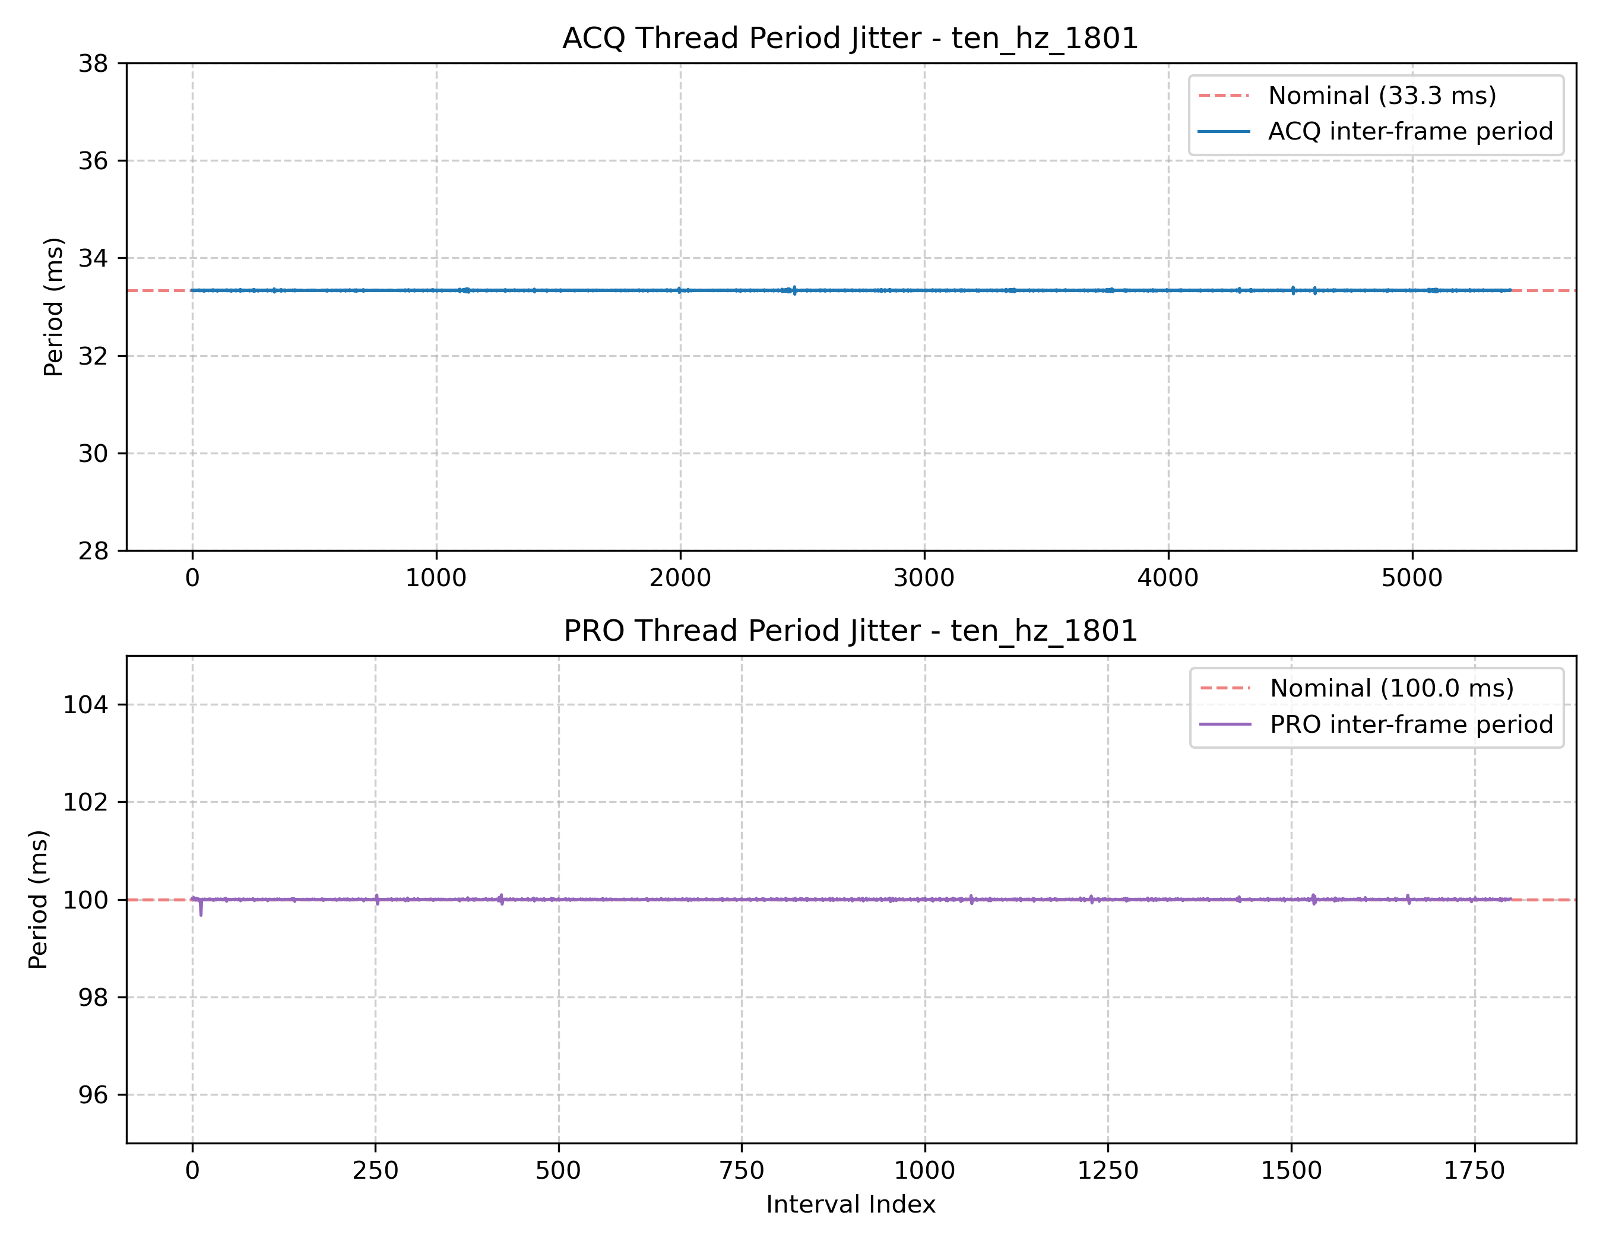
Ten Hz system jitter for 1801 frames test
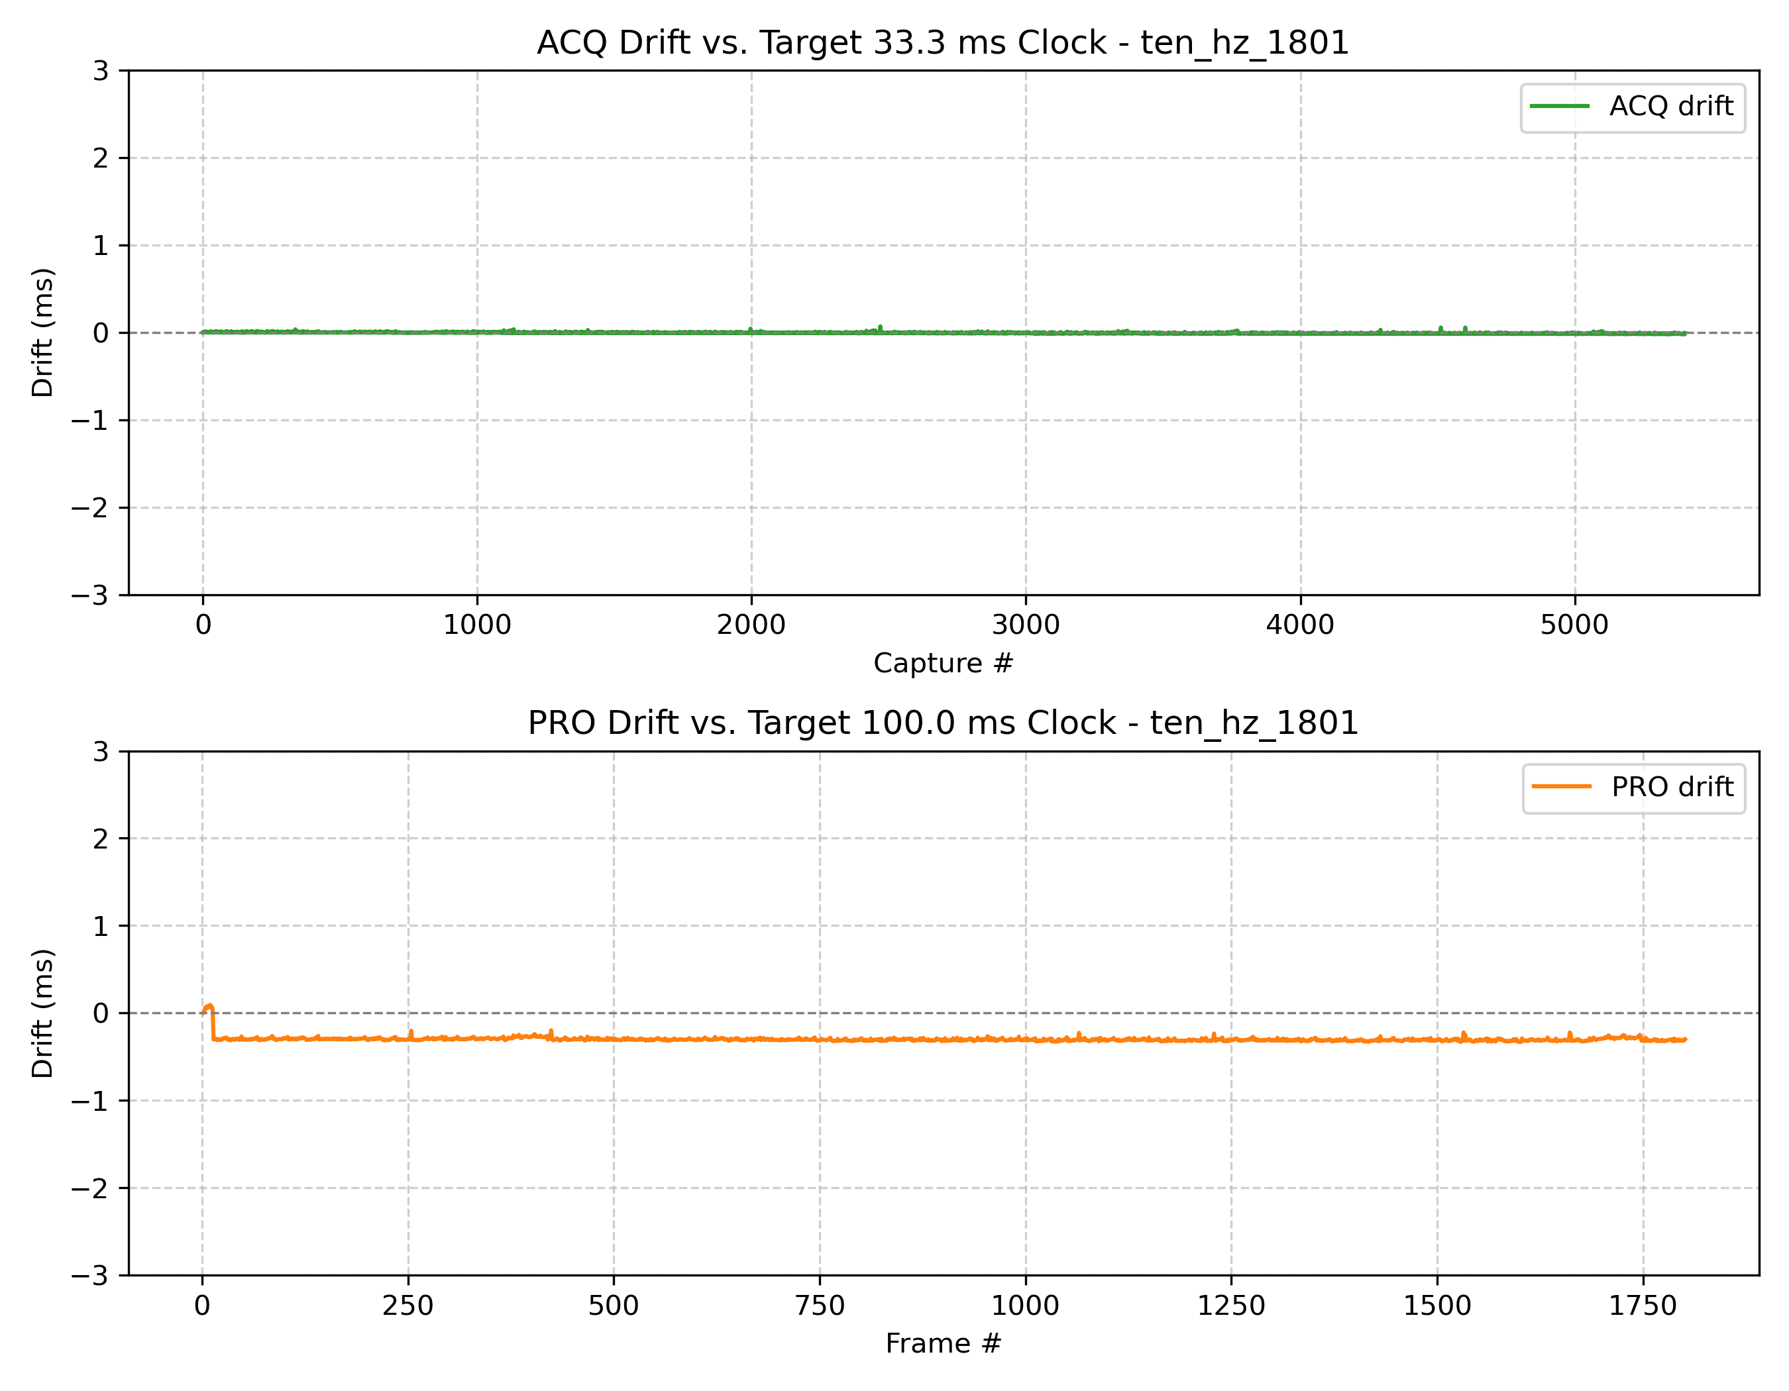
Ten Hz system drft for 1801 frames test

As seen in the figures above, there is a slight bit of drift in the Ten Hz application. Early on, there is an initial bit of latency which causes the application to run about 0.3ms behind the initially scheduled start time. This is likely due to the acquisition thread (higher priority) starting execution right before the processing thread. However, as demonstrated in the captured frames, this is negligible to the outcome of the application as it is less than 0.35ms of initial latency, much less than the 100ms period. The execution times of each thread are documented in Real-Time Analysis.

Conclusion
The project evolved through mutliple generations of real-time system architectures. Initial development implemented all real-time services on a single CPU core using Rate Monotonic scheduling to validate periodic task execution and feasibility analysis. While functionally correct, this design proved unreliable in practice because blocking SD card writes introduced timing variability that violated deterministic execution assumptions. The final implementation adopted a multi-core architecture using dedicated acquisition, processing, sequencer, and writer threads synchronized through semaphores and ring buffers. Real-time services executed under POSIX SCHED_FIFO scheduling with fixed priorities and CPU affinity, while the writer thread executed independently as a best-effort task to prevent blocking of higher-priority services. The resulting system successfully met both the 1 Hz and 10 Hz timing requirements, demonstrated predictable scheduling behavior, and validated the effectiveness of the real-time software architecture through frame captures and measured execution time, jitter, drift, and resource utilization.

References
[1] NVIDIA Corporation, "Monitoring Tools — Tegrastats Utility," NVIDIA Jetson Linux Developer Guide, Rel. 36.4, 2024. [Online]. Available: https://docs.nvidia.com/jetson/archives/r36.4/DeveloperGuide/AT/JetsonLinuxDevelopmentTools/TegrastatsUtility.html
[2] PlantUML, "PlantUML — Draw UML diagrams from plain text." [Online]. Available: https://www.plantuml.com/plantuml
[3] S. Siewert, "Real-Time Embedded Systems (RTES 5623) Course Resources Repository," ESEE Web Resources, University of Colorado Boulder. [Online]. Available: https://o365coloradoedu-my.sharepoint.com/

I would also like to acknowledge Dr. Sam Siewert for his guidance, mentorship, and instruction throughout this course and specifically during the development of this Final Project.

Appendix

GitHub repository: https://github.com/mamc3334/RTES_5623/tree/Project/Project

Downloadable Zip Files: Link

